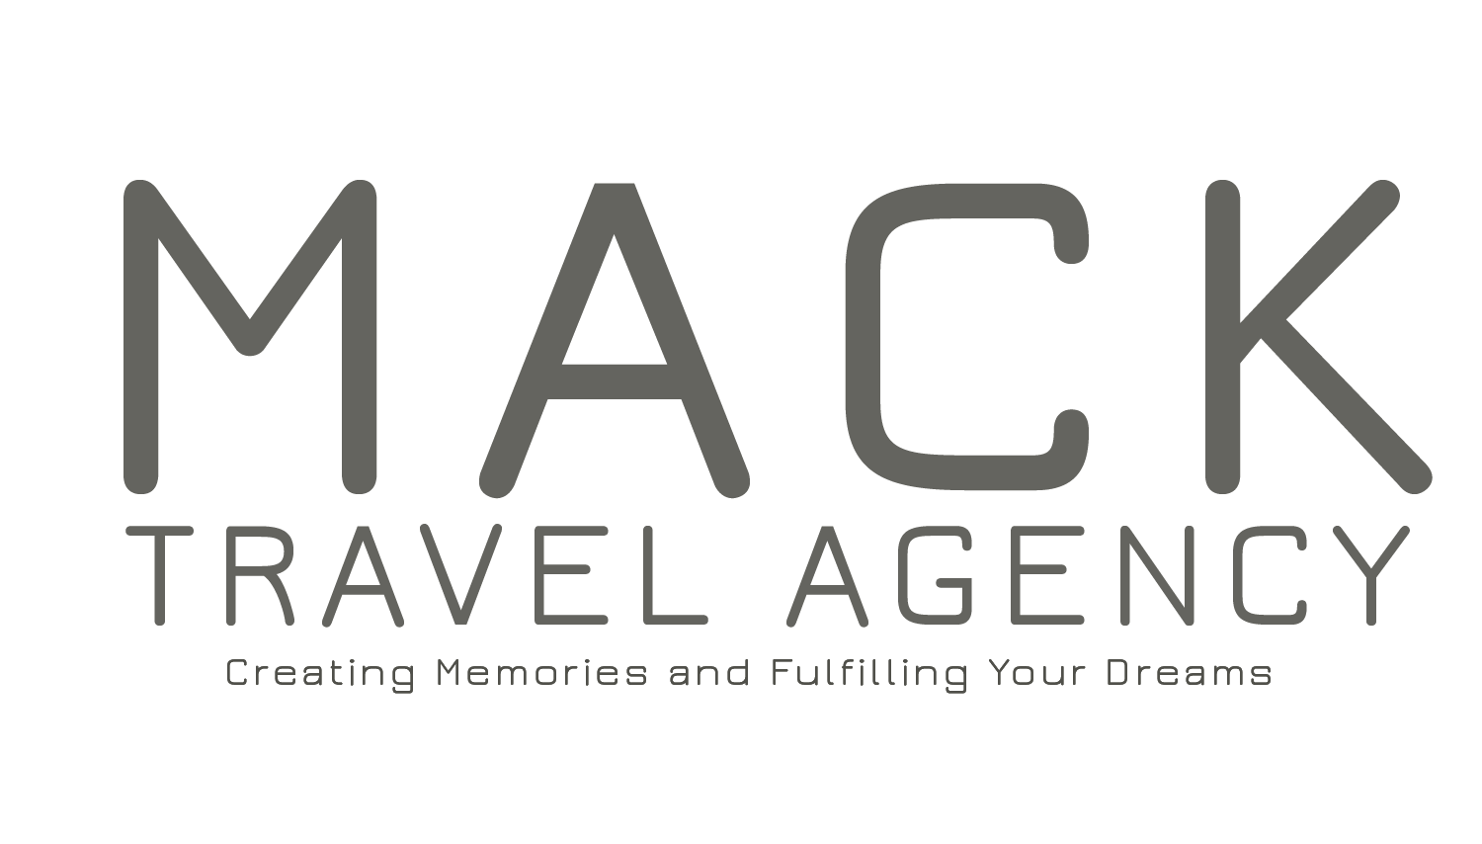

2119 Bessemer Road
Birmingham, AL 35208
Phone: (205) 945-6225
E-mail: fccc@mackstraveldesign.com
Website: www.macktraveldesign.com

CREDIT CARD PAYMENT AUTHORIZATION FORM

I ________________________________________ authorize Mack Travel Designer, LLC
(PRINT full name as shown on card)
to charge my credit/debit account indicated below for $ _____________ on or after the ________ day of each month beginning _________________, 2016 and ending ___________________, 2017. Payment(s) is for the 2017 FCCC Eight (8)-night Exotic Southern Caribbean Cruise.

Billing Address ______________________________________________________________________

City, State
_________________________________________________ Zip
__________________

Email Address ______________________________________________________________________

Phone(s) ( )
_______________________ or ( )
___________________________

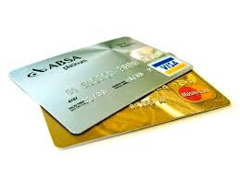
I authorize the above named business to charge the credit card indicated in this authorization form according to the terms outlined above. I certify that I am an authorized user of this credit card and that I will not dispute the payment with my credit card company; so long as the transactions corresponds to the terms indicated in this form.
Account Type:
[ ] Visa
[ ] MasterCard
[ ] AMEX
[ ] Discover
Cardholder’s Name _______________________________________________________________
Account Number _________________________________________ Exp Date _______/_______ CVV2 (3-digit number on back of Visa/MasterCard; 4 digits on front of AMEX) ________________

Signature Date / /

